A Theory of Aging
Jason Albanese

Atamna H. et al. (2008). Methylene blue delays cellular senescence and enhances key mitochondrial biochemical pathways. The FASEB Journal, 22, 703-712.

Bokov A., Chaudhuri A., and Richardson A. (2004). The role of oxidative damage and stress in aging. Mechanisms of Ageing and Development, 125, 811-826.

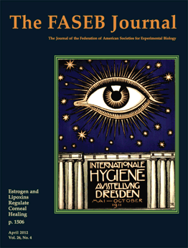
Time is often called human-kind’s worst enemy. As time progresses, we age. As we age, wits dull, strength ebbs, and beauty fades. Time is an unstoppable force and aging is a given. However, some people age faster than others and to different extents. We cannot stop aging altogether, but clearly we can prolong our lives and perhaps our youth. Thus, aging is a major topic of research as people scramble to understand this complex process that affects us all.
The predominant theory of aging involves accumulated damage to the body’s cells over time. This damage is thought to be caused by a random process of oxidation. Oxidation is a chemical process by which energy is added to a molecule. High-energy molecules become unstable and often do not function as the cell intends. As its name suggests, oxidation is often associated with high-levels of oxygen and other highly reactive compounds usually containing oxygen. Accumulation of such compounds and the damage they cause over time is considered the driving force causing dysfunction of the body’s cells. Once enough damage has been done to a cell, the cell stops growing and functioning properly – a process called cellular senescence – and eventually dies. Senescent cells lead to the features we develop as we age. This theory is known as the Free Radical and Oxidative Stress Theory of Aging.
Aging is not just a concern for old people. Many premature aging diseases affect children, causing them to age at a much faster pace than normal humans. One such disease, Hutchinson-Gilford Progeria Syndrome, has garnered a great deal of publicity. Progeria is a genetic disorder caused by a DNA mutation before or shortly after conception. Progeria affects a child from birth, causing rapid aging and stunted growth. Most individuals afflicted with Progeria die by 14 from a heart attack or stroke. Progeria is used as a model to study aging. Studying the aging process can lead to effective treatments for the disease, as well as enhanced understanding of aging in general.
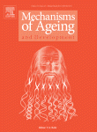
A tremendous amount of resources are devoted to studying aging. Dr. Alex Bokov is a researcher who studies aging. Bokov is a young gerontologist currently working at the University of Texas. Despite his youth, Bokov has proven to be an exceptional researcher and has published many important papers including a comprehensive review of the Free Radical and Oxidative Stress Theory of Aging.
Dr. Hani Atamna is another of the well-known researchers studying aging. Atamna is a highly published neuroscientist. His research has received a lot of attention recently due to his discoveries and characterizations of drugs that can delay aging and improve overall health.
Atamna’s and his colleagues’ recent research on the drug methylene blue suggests its ability to delay aging. Methylene blue is a blue compound used for a wide variety of functions. Methylene Blue is a vital stain used to visualize DNA, an indicator in forensics for the presence of fingerprints, an indicator for the presence of oxygen, and an FDA approved treatment for malaria and septic shock. Atamna et al. used methylene blue to treat a culture of human tissue cells. They found that the treated cells lived longer and grew faster at the proper treatment dose. Atamna et al. also treated the cells starting at different cellular ages, measured by the number of times the number of cells had doubled. They report that methylene blue can delay the senescence of human cells at any cell age, though the treatment is more effective when used on younger cells. This finding supports the idea that aging is a cumulative effect.
Atamna et al. further studied the process behind the methylene blue treatment and proposed a mechanism. Atamna et al. focused on mitochondria, small organelles found in human cells that produce energy. They reported that methylene blue enhanced the energy production of the cells while reducing the oxidant production, which is usually associated with mitochondrial activity. Atamna et al. also found that methylene blue activates two enzymes that defend against and eliminate reactive compounds that lead to oxidative damage. The authors suggest that methylene blue reduces the production of oxidizing compounds and leads to the elimination of even more and that this function give methylene blue its anti-aging effect.
Hani Atamna, Ph.D.

Obtained from: The Commonwealth Medical College
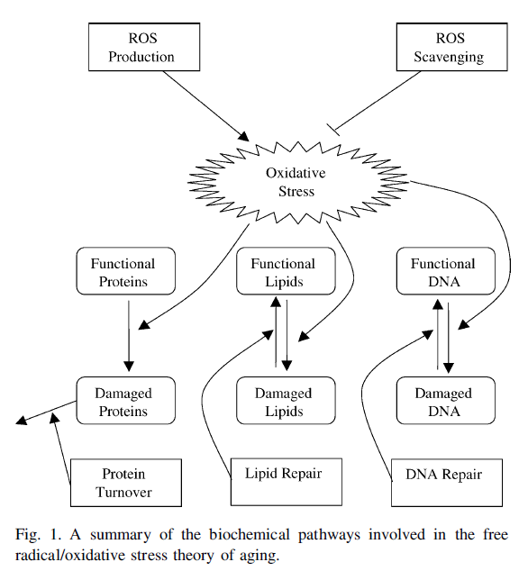
The findings of and mechanism proposed by Atamna et al. support the Free Radical and Oxidative Stress Theory of Aging. This theory is comprehensively evaluated by Bokov et al. in a review article. They begin by clearly defining the Free Radical and Oxidative Stress Theory of Aging, which had not been previously well-defined. The authors then use three predictions of the theory to define a comprehensive test to validate the theory. These predictions are that levels of oxidizing compounds will be higher in more aged individuals and cells than in younger ones, treatments that promote longevity will reduce the levels of these oxidizing compounds, and that reducing the levels of oxidizing compounds will promote longevity.
A summary of the biochemical pathways involved in the free radical/oxidative stress theory of aging (Bokov et al., 2004).
Bokov et al. report that a comprehensive data set has been collected supporting the first two predictions. However, the third prediction is not well-supported. The studies on fruit flies and mice are inconclusive or contradictory; therefore, the authors suggest that research be focused on the prediction that reducing the levels of oxidizing compounds in cells increases the lifespan of the organism. Without this, the data supporting the Free Radical and Oxidative Stress Theory of Aging is purely correlational and not causative. The study by Atamna et al. adds support in favor of the unverified prediction in human cells. However, more research must still be done.
Support is mounting for the Free Radical and Oxidative Stress Theory of Aging. The theory has been popular since the mid to late 70s. I believe that the three predictions of the theory defined by Bokov et al. will soon be verified. However, I believe that the theory does not tell the whole story. The theory is misleading in that it suggests that aging is an entirely random occurrence. The existence of genetic premature aging diseases, such as Progeria, suggests that aging is partially a function programmed into all cells and not entirely a summation of random events. Free radicals and oxidative compounds are likely a major contributing factor to aging and the cell’s programmed response may in part be a response to the accumulation of such molecules. However, more research is needed to gain a more complete picture of why we age.

